Project Design Phase-II
Technology Stack (Architecture & Stack)

Date | 31 January 2026
Team ID | LTVIP2026TMIDS60355
Project Name | Calculating family expenses using service now
Maximum Marks | 4 Marks

Technical Architecture:
The Deliverable shall include the architectural diagram as below and the information as per the table1 & table 2

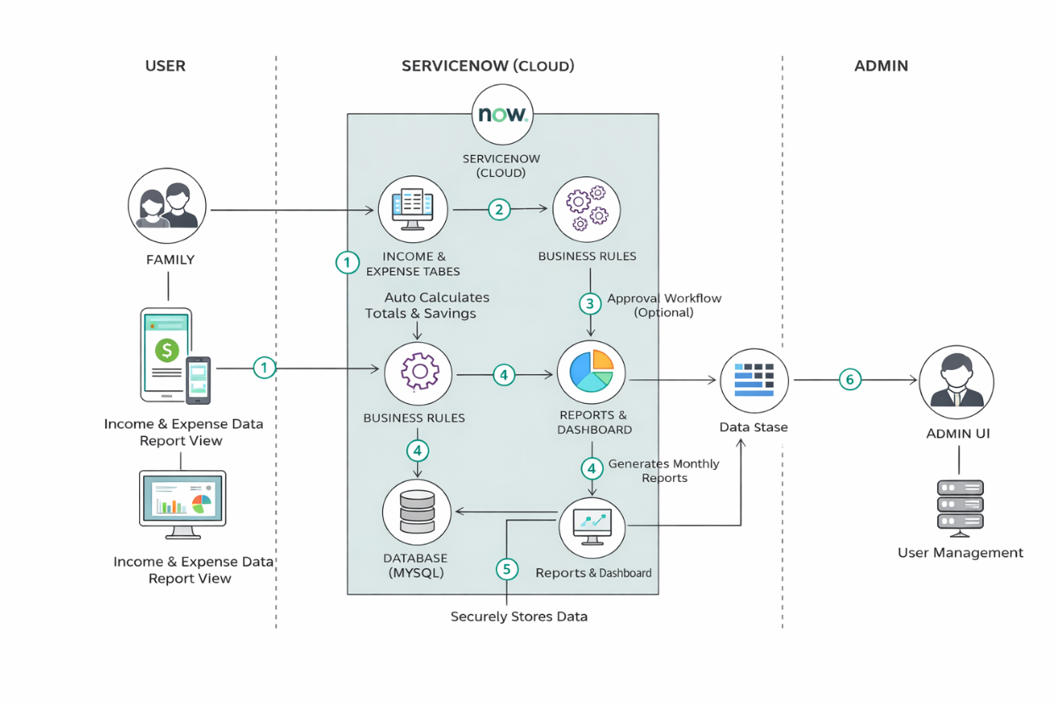

Table-1: Components & Technologies:
S.No | Component | Description | Technology
1 | User Interface | How user interacts with the application (Forms, Dashboard, Reports) | ServiceNow UI, HTML, CSS
2 | Application Logic-1 | Logic for managing Income records | ServiceNow Business Rules, Scripts
3 | Application Logic-2 | Logic for managing Expense records | ServiceNow Business Rules, Client Scripts
4 | Application Logic-3 | Logic for calculating totals and savings | Script Includes, Glide API
5 | Database | Stores income, expense, category and user data | ServiceNow Tables (MySQL backend)
6 | Cloud Platform | Platform where application is hosted | ServiceNow Cloud Platform
7 | File Storage | Stores attachments or supporting documents | ServiceNow Attachment System
8 | Reporting Engine | Generates reports and graphical dashboards | ServiceNow Reports & Performance Analytics
9 | Authentication System | Handles login and user verification | ServiceNow Authentication & ACL
10 | Workflow Automation | Automates approval or notification processes | ServiceNow Flow Designer
11 | Infrastructure (Server / Cloud) | Application deployment and hosting environment | ServiceNow SaaS (Cloud-based infrastructure)

Table-2: Application Characteristics:
S.No | Characteristics | Description | Technology
1 | Open-Source Frameworks | Platform and frameworks used for developing the application | ServiceNow Platform (SaaS), HTML, CSS, JavaScript
2 | Security Implementations | Security controls implemented such as authentication, authorization, encryption, and access control | ServiceNow ACL, Role-Based Access Control (RBAC), HTTPS (SSL/TLS), Data Encryption
3 | Scalable Architecture | Cloud-based architecture supporting multiple users and scalable data storage | ServiceNow Cloud Infrastructure (Multi-tenant SaaS Architecture)
4 | Availability | Ensures application is accessible 24/7 with minimal downtime | ServiceNow Cloud Hosting, High Availability Data Centers
5 | Performance | Optimized data processing, quick calculations, and fast report generation | ServiceNow Business Rules, Indexed Tables, Caching Mechanisms

